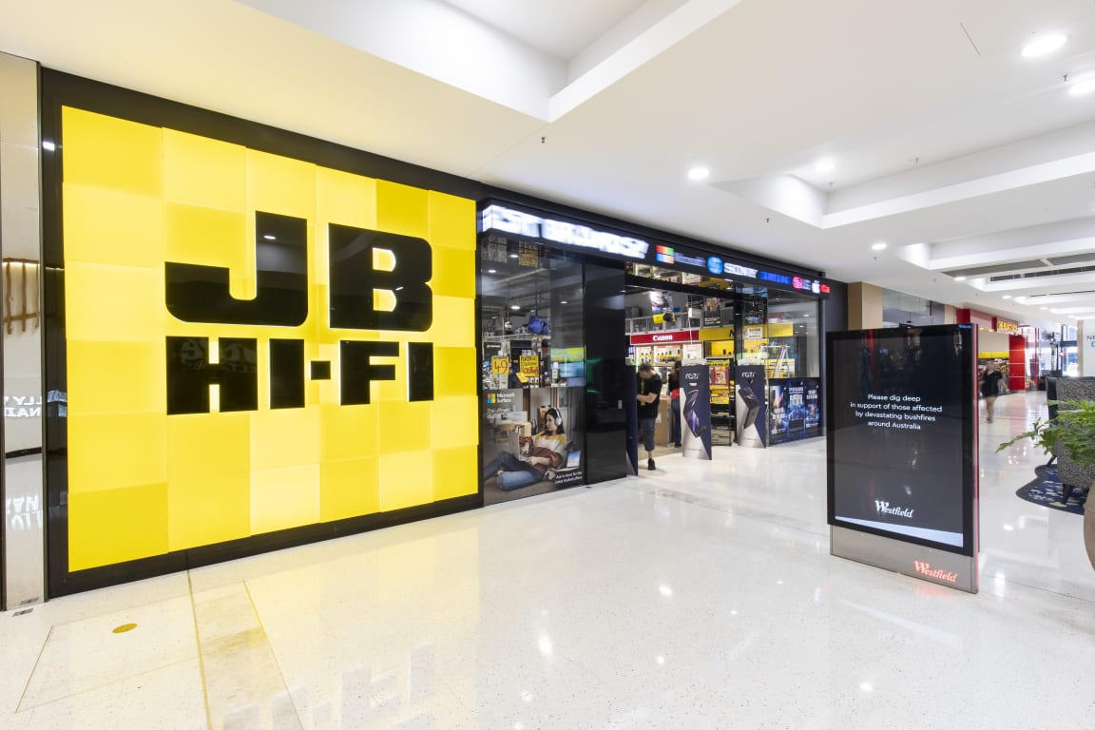


PREPARED FOR
NAME, LECTURER, COURSE, STRATEGIC SUPPLY CHAIN MANAGEMENT
PREPARED BY
WORD COUNT: 825

SUPPLY CHAIN STRATEGY MODEL

- JB HI-FI: Company Overview
JB Hi-Fi is among the largest and most recognized retail companies in Australia dealing with consumer electronic products as well as video games, CDs and Blu ray. Despite being a retailer, the company also owns a series of chain stores to provide their products using online websites together with other existing network channels (JB Hi-Fi, 2020). With its headquarters located in Melbourne, Australia JB Hi-Fi provides a variety of entertainment products in specific places at an affordable and lower price than any other company in Australia thus becoming appealing to their customers as well as other new clients. Besides, their goal is to deliver quality products at lower prices by upholding the top supply chain network than all their competitors. Through that, they do preserve their operating cost as low as possible to offer their products at a competitive price. Focusing on the growth rate of home entertainment in Australia, JB Hi-Fi has intensified on the home entertainment market and thus yielding more returns from the sales (Yang, 2018). Also, the music industry is expanding significantly, therefore the need for recording and domestic appliances increases which have made the company focus on the products needed to support the activities. Therefore, this report will focus on realizing the supply chain drivers, identify an issue affecting the supply chain strategy as well as the theory to be applied to counter the supply chain issue.

Figure 1: JB Hi-Fi products.
- JB Hi-Fi Supply Chain
According to Coles (2020), JB Hi-Fi attained mobility in supply chain network by combining suppliers from Australia and abroad who will supply to the company in the country. Also, the company has utilized an executive purchasing authority program where the supply chain process is administered by a real-time tracking system permitting advanced together with faster data accessibility aiding in making decision process. Moreover, supply chain network and leaner functions effective and quicker in distributing products at a time as well as decreasing the total cost used in logistics supervision (Paul & Rahman, 2018). Besides, the company relies fully on suppliers from abroad thus importing their goods to maintain its working capital at the same time reduce interest amount. To maintain product quality and save on timely delivery of commodities from their suppliers abroad, JB Hi-Fi has employed agents in all countries where they source their products thus eradicating homegrown brokers and middleman.
JB Hi-Fi utilizes four key supply chain drivers that monitor the supply of products, which are communication, store evaluation, stock on floor and customer service. Since the company is an online retailer, it should keep checking the stocks available for swift and appropriate procurement of products from the store. With goods being stored in warehouses and every product having a tag as well as preserving the interval of moving products from different places, tracking is performed in real-time thus limiting the handling of goods (Yang, 2018). Furthermore, communication is enhanced between different levels in the company to ensure goods are supplied to customers effectively and in an organized way.
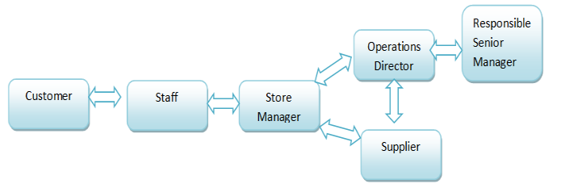
Figure 2: Different elements in JB Hi-Fi supply chain network.
Since the company does not manufacture the products they sell, JB Hi-Fi relies on its loyal suppliers to sustain the stream of products in an aggravation free and justifiable manner. Furthermore, due to their value for money and excellent customer service, JB Hi-Fi has managed to increase its financial flows significantly over the years (Grimmer, 2019). Also, the revenues have increased in the strong store network and enhanced supply chain management. The capital investment in the company is working well and operates at around fifty million dollars to sixty million dollars annually. Moreover, within six months the total online sales increased by 18.3 percent to 170.8 million dollars (JB Hi-Fi, 2019).
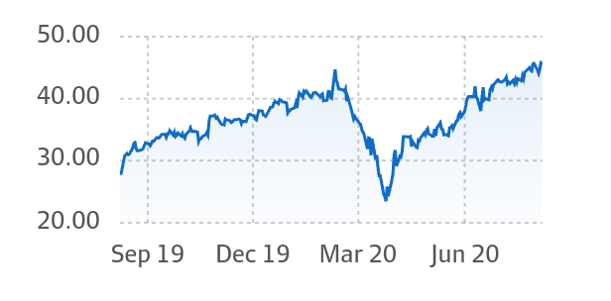

Figure 3: JB Hi-Fi financial review source: financialreview.com
- Potential Challenges
Although JB Hi-Fi works hard towards preserving a timely and effectual delivery of products to its customers, they are still faced with challenges from their suppliers and distributions of goods to their customers. The first challenge emerges during the obtaining of products from abroad which requires JB Hi-Fi Company to be authorized by the Australian government through the signing of a written form (Yang, 2018). The process takes a lot of time which leads to delays and thus affecting their operations. Lastly is the issue of safety of the goods imported by the company. Despite the company having a variety of products to sell, they do not have an appropriate supply chain management program in overseeing supply of commodities. Since the process is driven by workers and technology majority of their goods keeps changing rapidly and will be deemed outdated.
- Conclusion
To ensure an efficient supply chain, JB Hi-Fi should use some of its working capital in obtaining stocks in advance to reduce the risks of getting stocks late. Also, maintaining communication with their network will be of great help in ensuring an appropriate supply of products.
References
Boyd, T. (2020). How JB Hi-Fi went from good to great. https://www.afr.com/chanticleer/how-jb-hi-fi-went-from-good-to-great-20200210-p53z9z
Coles, B. (2020). $44 Million warehouse will become new delivery centre for JB HI-FI. http://mhdsupplychain.com.au/2020/01/29/44-million-warehouse-will-become-new-delivery-centre-for-jb-hi-fi/
Grimmer, L. (2019). Market snapshot: Australia: interview with Elias Jahshan.
JB Hi-Fi. (2020). JB HI-FI: About Us. https://www.jbhifi.com.au/pages/about-us
JB Hi-Fi. (2019). JB HI-FI: ANNUAL REPORT. https://investors.jbhifi.com.au/wp-content/uploads/2019/10/Annual-Report-2019-with-Chairmans-CEOs-Report.pdf
Paul, S. K., & Rahman, S. (2018). A quantitative and simulation model for managing sudden supply delay with fuzzy demand and safety stock. International Journal of Production Research, 56(13), 4377-4395.
Yang, D. (2018). Has the arrival of Amazon altered the market structure for consumer electronic goods in Australia?

Appendices
Appendix A: JB Hi-Fi Limited's (ASX:JBH) Returns

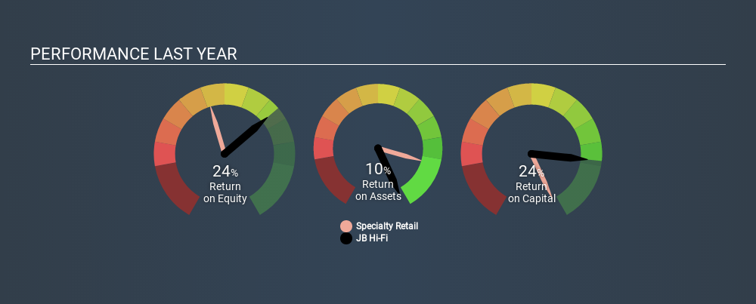

JB Hi-Fi Limited's (ASX:JBH) Returns, adapted from Simply Wall St. (2020). Are JB Hi-Fi Limited’s (ASX:JBH) High Returns Really That Great?

